**Institute of Computer Technology**

**B. Tech. Computer Science and Engineering**

**Semester: III**

**Sub: Object-Oriented Programming**

**Course Code: 2CSE303**

**Practical Number: 11**

**Objective:**

*To learn about exception handling concepts in Java.*

1. Explain exception, and exception handling concept in java.

**ANS :**

Exception: An exception is an event that disrupts the normal flow of a program during runtime. It is an object representing an error condition.

Exception Handling: It is a mechanism to handle runtime errors, ensuring the normal flow of the program.

1. What is the difference between exception and error in java? Explain with an example.

**ANS :**

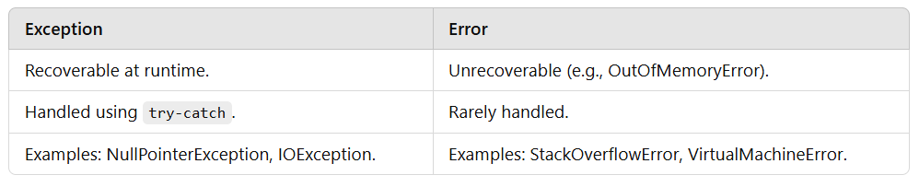

1. Explain the concept of try and catch block in java exception handling with an appropriate program example.

**Code :**

public class TryCatchExample {

public static void main(String[] args) {

try {

int data = 50 / 0;

} catch (ArithmeticException e) {

System.out.println("Caught Exception: " + e);

}

}

}

1. Explain throw and throws concept in java exception handling with an appropriate program example.

**ANS :**

Throw: Used to explicitly throw an exception.

Throws: Used in method declaration to indicate exceptions the method can throw.

E.g

class ThrowThrowsExample {

void checkAge(int age) throws IllegalArgumentException {

if (age < 18) {

throw new IllegalArgumentException("Age is not valid!");

}

}

public static void main(String[] args) {

try {

new ThrowThrowsExample().checkAge(15);

} catch (IllegalArgumentException e) {

System.out.println("Exception: " + e.getMessage());

}

}

}

1. Explain the concept of multiple catch block in java exception handling with an appropriate program example.

**Code :**

public class MultipleCatchExample {

public static void main(String[] args) {

try {

int[] arr = new int[5];

arr[5] = 10 / 0;

} catch (ArithmeticException e) {

System.out.println("Arithmetic Exception");

} catch (ArrayIndexOutOfBoundsException e) {

System.out.println("Array Index Out of Bounds");

}

}

}

1. Explain the concept of finally block in java exception handling with an example.

**Code :**

public class FinallyExample {

public static void main(String[] args) {

try {

int data = 10 / 0;

} catch (ArithmeticException e) {

System.out.println("Exception: " + e.getMessage());

} finally {

System.out.println("Finally block executed");

}

}

}

**Error :**

**OutOfMemoryError**

1. Explain hierarchy of the exception class with an appropriate diagram example.

**Code :**

**Output :**

1. Write an appropriate program of the following checked exception
2. IOException.

**Code :** import java.io.*;

public class IOExceptionExample {

public static void main(String[] args) {

try {

FileReader fr = new FileReader("nonexistent.txt");

} catch (IOException e) {

System.out.println("IOException occurred: " + e.getMessage());

}

}

}

1. FileNotFoundException.

**Code : i**mport java.io.*;

public class FileNotFoundExceptionExample {

public static void main(String[] args) {

try {

FileReader fr = new FileReader("missingfile.txt");

} catch (FileNotFoundException e) {

System.out.println("FileNotFoundException occurred: " + e.getMessage());

}

}

}

1. ClassNotFoundException.

**Code :** public class ClassNotFoundExceptionExample {

public static void main(String[] args) {

try {

Class.forName("NonExistentClass");

} catch (ClassNotFoundException e) {

System.out.println("ClassNotFoundException occurred: " + e.getMessage());

}

}

}

1. SQLException.

**Code :** import java.sql.*;

public class SQLExceptionExample {

public static void main(String[] args) {

try {

Connection conn = DriverManager.getConnection("invalid-url", "user", "pass");

} catch (SQLException e) {

System.out.println("SQLException occurred: " + e.getMessage());

}

}

}

1. InterruptedException

**Code :** public class InterruptedExceptionExample {

public static void main(String[] args) {

Thread t = new Thread(() -> {});

t.start();

try {

t.join();

} catch (InterruptedException e) {

System.out.println("InterruptedException occurred: " + e.getMessage());

}

}

}

1. Instantiation Exception

**Code :** public class InstantiationExceptionExample {

public static void main(String[] args) {

try {

Class<?> clazz = Class.forName("java.util.ArrayList");

Object obj = clazz.newInstance();

} catch (InstantiationException | IllegalAccessException | ClassNotFoundException e) {

System.out.println("Exception occurred: " + e.getMessage());

}

}

}